Online Airlines Reservation System:

Problem Statement:

Passenger can view all the available flights. To book a ticket passenger must login into the system. After login admin will verify the login. He/she can book the ticket.. The passenger may check for discount on flight after three flights from that airline. Before making payment he/she should confirm the ticket. Payment should be done to bank.

Cancellation of ticket after payment passenger will only receive half of amount as refund. The admin updates flight details.

Actors: passenger, Admin, Bank

Use cases: view flight, login, verify login, book ticket, ticket confirmation, payment, cancellation of ticket, refund, update flight details

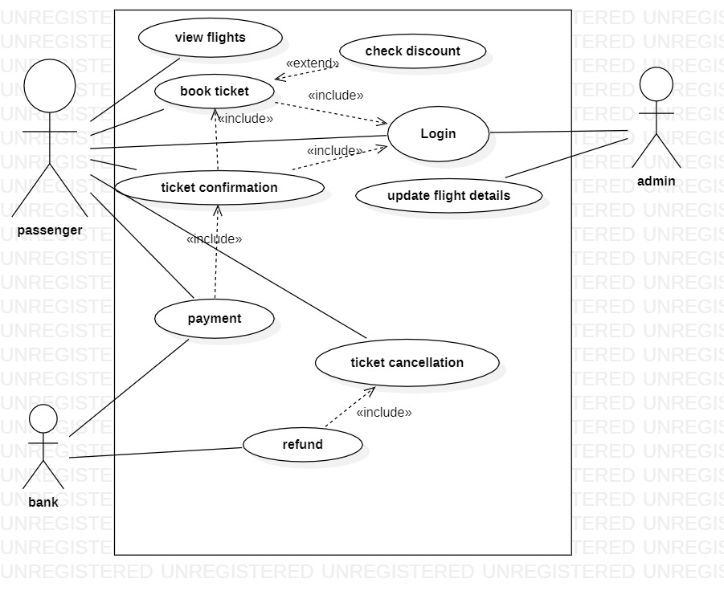

Online Library management System:

Problem statement:

Student must login into college website then only he/she can view the books. Admin will verify the login.

Student can search the book he want. If the book is available student can take the book from college. The librarian will assign the return date on book. If student fails to return book on estimated time fine will be charged for the book. Librarian will provide update about new books available in library. Student can request admin for new books.

Actors: student, Librarian, Admin

Use cases: Search books, take book return books, Pay fine, request new books, update books, login, verify login

